JSS2 MATHS

3RD TERM 2016

1. Which of the following is not a factor of 72 A. 72 B. 36 C. 24 D. 15
2. What percentage of 4m is 20cm A. 2.5 B. 5 C. 20 D. 30
3. Two angles are said to be complementary if there sum is A. 60⁰ B. 90⁰ C. 180⁰ D. 360⁰
4. If 6 $\frac{3}{4}$ is expressed as an improper fraction, its numerator will be A. 3 B. 6 C. 24 D. 27
5. The area of a triangle is 54cm². if the height of the triangle is 6cm, find its base A. 9cm B. 12cm C. 18cm D. 21cm
6. Convert 1010₂ to base 10 A. 6 B. 8 C. 10 D. 12
7. In a right angle triangle, the side opposite the right angle is known as A. obtuse B. hypotenuse C. parallel D. scalene
8. Express 1101₂ in denary A. 27 B. 20 C. 13 D. 11
9. Find the perimeter of a hexagon with side 5cm A. 20cm B. 26cm C. 30cm D. 36cm
10. How many line of symmetry does a square have? A. 0 B. 1 C. 2 D. 3
11. How many vertices does a cube have A. 8 B. 10 C. 12 D. 16
12. What is square root of $\frac{49}{121}$ A. 2/7 B. 4/7 C. 7/11 D. 7/9
13. The volume of a cuboid is 24cm³. if the base is 6cm by 2cm, find the height of the cuboid A. 2cm B. 3cm C. 4cm D. 5cm
14. What is the square of the HCF of 60 and 108? A. 30 B. 36 C. 120 D. 144
15. A basket contains 40mangoes, out of which 22 are good. Find the percentage of the mangoes that are bad A. 18 B. 22 C. 24 D. 45
16. What is the sum of the interior angle of an octagon A.680⁰ B. 720⁰ C. 1080⁰ D. 1200⁰
17. Which of these angle is complementary to 70⁰ A. 20⁰ B. 30⁰ C. 90⁰ D. 110⁰
18. The sum of supplementary angles is A.90⁰ B. 180⁰ C. 240⁰ D. 360⁰
19. Find the exterior angle of a regular decagon A. 30⁰ B. 36⁰ C. 40⁰ D. 45⁰
20. Find the sum of 3x, (1 – 6x), 4x and x A. 1 – 2x B. 1 – 3x C. 2x + 1 D. 2x – 1
21. A number which is one more than n is A. 1 – n B. n + 1 C. n -1 D. 2n
22. Find the value of - 5 - (- 20) A. – 30 B. -25 C. -15 D. 15
23. Express 33% as a decimal number A. 0.30 B. 0.31 C. 0.32 D. 0.33
24. Approximate 13075 to the nearest thousand A. 13000 B. 13015 C. 13045 D. 13065
25. Convert 2/3 to decimal fraction and give your answer to 2 decimal places A.0.76 B. 0.70 C. 0.67 D. 0.66
26. Find the L.C.M of 15 and 45 A. 30 B. 45 C. 60 D. 75
27. Find the perimeter of a football field of length 100m and breadth 60m A. 600m B. 450m C. 320m D. 200m
28. Which of the following is not a plane shape A. rectangle B. cube C. triangle D. square
29. In solid shape, a flat surface is referred to as A. edge B. face C. side D. vertex
30. What is the complement of 63⁰ A. 57⁰ B. 47⁰ C. 37⁰ D. 27⁰
31. What is the radius of a circle of diameter 44cm A. 7cm B. 11cm C. 13cm D. 22cm
32. What is the perimeter of a regular decagon of side 3.25cm each A. 26.5cm B. 28.5cm C. 32.5cm D. 40cm
33. What is the value of the angle marked w in the diagram below

9A. 97⁰ B. 83⁰ C. 79⁰ D. 180⁰

1. What is the value of angle YXZ in the diagram given below

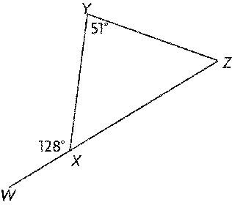A. 52⁰ B. 62⁰ C. 77⁰ D. 87⁰

1. Using the diagram in question 34 above, find the value of angle YZX A. 52⁰ B. 62⁰ C. 77⁰ D. 87⁰
2. MCj02508370000[1] The name of the shape is A. solid B. cone C. cylinder D. milk tin
3. 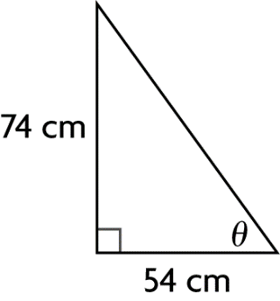 The side with value of 54cm is called A. hypotenuse B. opposite C. adjacent D. angle
4. The side with value of 74cm is called A. hypotenuse B. opposite C. adjacent D. angle
5. The side facing the 90⁰ is known as the A. hypotenuse B. opposite C. adjacent D. angle
6. What is the value of the Roman numeral MXCV A. 1000 B. 1065 C. 1095 D. 1600
7. Express 52 as a product of its prime factors A. 2 x 13 X 13 B. 2 X 26 C. 2 X 2 X 13 D. 4 x 13
8. What is the value of each exterior angle of a regular octagon? A. 150⁰ B. 100⁰ C. 90⁰ D. 45⁰
9. Find the square root of 4x² A. x B. 2x C. 3x D. 16x
10. Simplify 4(r + 3t) -4(2t - r) A. 4(2r + t ) B. 8r + t C. 4(2r –t) D. 4t
11. Evaluate 2  +  + 7  A.9  B. 9  C. 10  D. 10 
12. Express 47 % as a decimal. A. 0.0047 B. 4.7 C. 0.47 D. 470
13. What is of 27? A. 9 B. 18 C. 40.5 D. 54
14. Which decimal represents  ? A. 0.125 B. 0.58 C. 0.6 D. 0.625
15. What is the best estimate for the percentage that is **shaded in the diagram**?
16. 33% B. 50% C. 66% D. 110%
17. Write the fraction in simplest form (lowest terms) A. 6/28 B. 4/7 C. 8/14 D. 9/14

THEORY